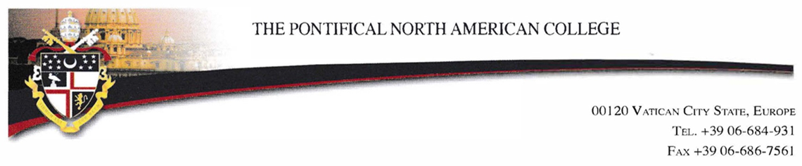

Date: June 1, 2023
Re: Pastoral Assignment Information

Dear Pastor or Supervisor,

Thank you for hosting a seminarian of the North American College during his pastoral placement. The pastoral experience is an extremely important time in the seminarian’s formation for priesthood, and your role in his formation is crucial. I have asked the seminarian to provide you with this letter and the accompanying forms so that you might understand the expectations of the College.

Since the development of public speaking and preaching skills are very important, I encourage you to offer him opportunities to develop these skills in a setting appropriate with his stage of formation. If he is an ordained deacon, please offer him the opportunity to preach and to exercise his diaconal ministry whenever possible.

At the beginning of the assignment:

- Review the document “Pastoral Placement SUGGESTIONS” which offers a list of pastoral opportunities to consider.
- Fill out the “ASSIGNMENT EXPECTATIONS” shortly after he arrives.
- Review the “Supervisor Evaluation” at the start of his parish assignment so that you understand what criteria will be used for his evaluation.
- Please meet weekly to provide him with regular feedback.

At the end of his assignment:

- Complete the “Supervisor Evaluation” and ask a staff member or parishioner to fill out the “Staff Member Evaluation.” If possible, please type your responses. The seminarian should have these forms. They can also be downloaded at www.pnac.org
          - Click on Admissions
          - Click on Vocation Director Resources
          - Look under heading Parish Pastoral Assignment Forms
- After the forms are completed, please review them with the seminarian.

The seminarian has been informed that he needs to send one copy of the forms to the Vocation Director in his diocese and to bring the original forms with him when he returns to the College. We ask that you NOT mail the evaluation to the seminary. It works better to have the seminarian hand deliver the forms to the Coordinator of Apostolic Formation. If you have a concern about giving the forms directly to him, please notify me via email or phone call. If you have diocesan evaluation forms that are similar to ours, it is not necessary to complete both sets of forms. We are happy to take a copy of your diocesan forms.

The evaluations are essential to our program. The seminarian will review his evaluation with his formation advisor, and the faculty incorporates the evaluation into its annual evaluation of the seminarian. I am very grateful for your support and ministerial guidance of the seminarian in your care.

Sincerely yours in Christ,

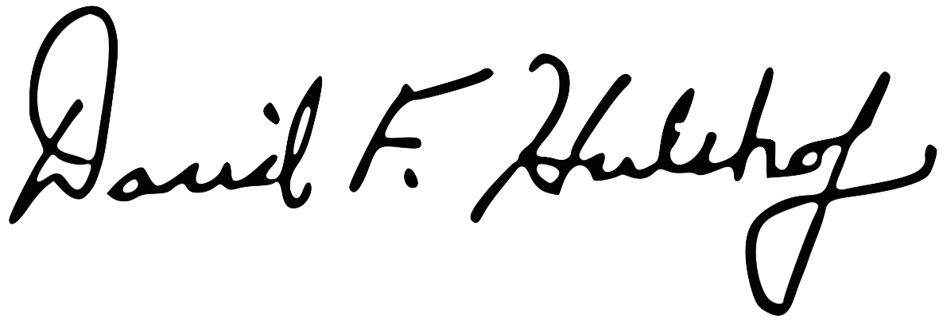
Rev. David F. Hulshof
Coordinator of Apostolic Formation
dhulshof@pnac.org

